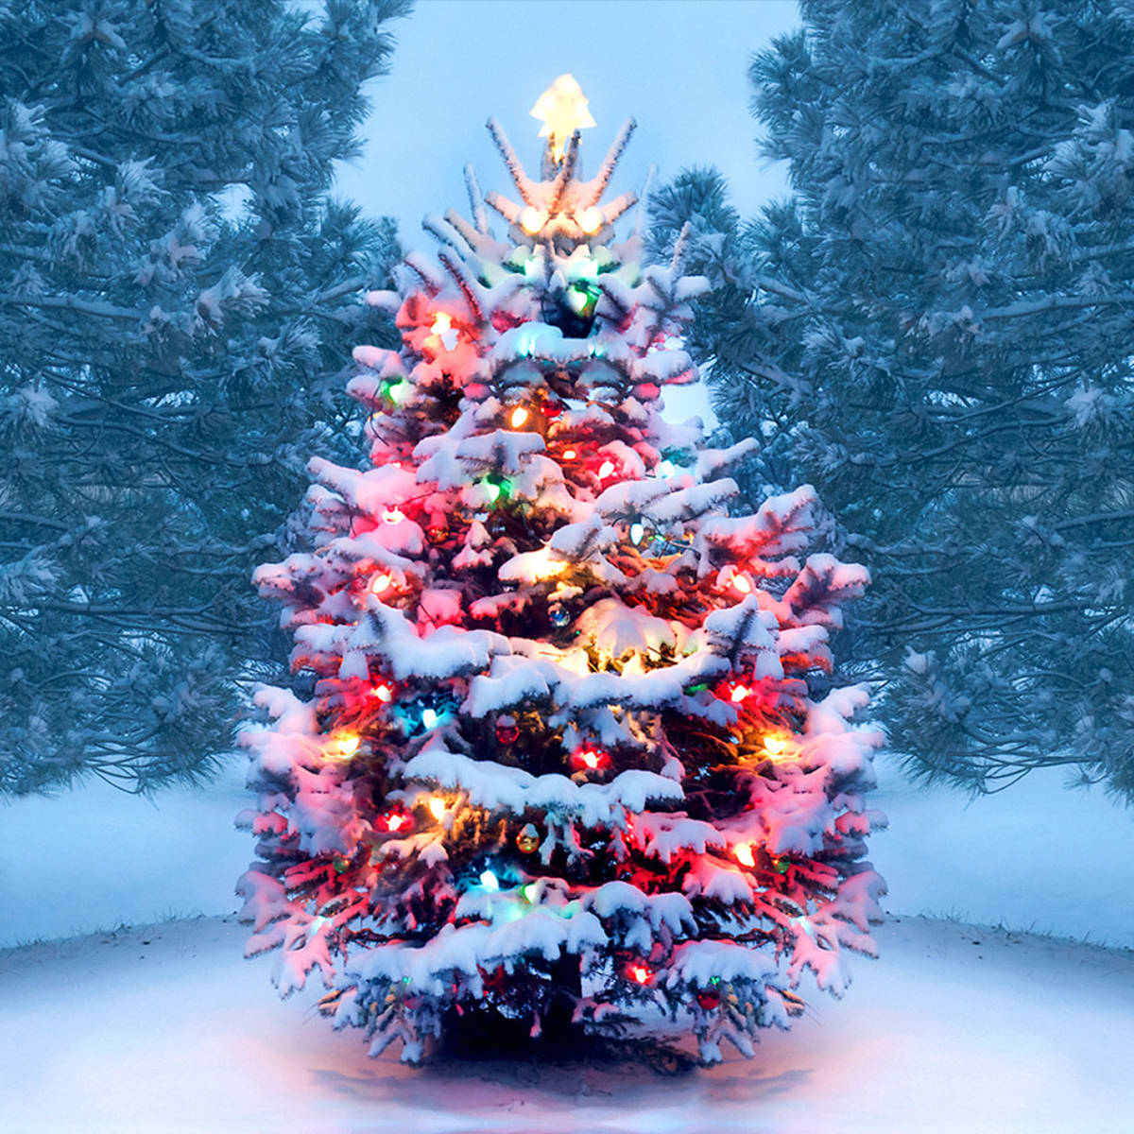
What a busy half term we have had in the lead up to Christmas. We are all getting excited and can’t wait to tell you what has been happening around school. We want to wish everyone a Merry Christmas and happy New Year

Forest Schools
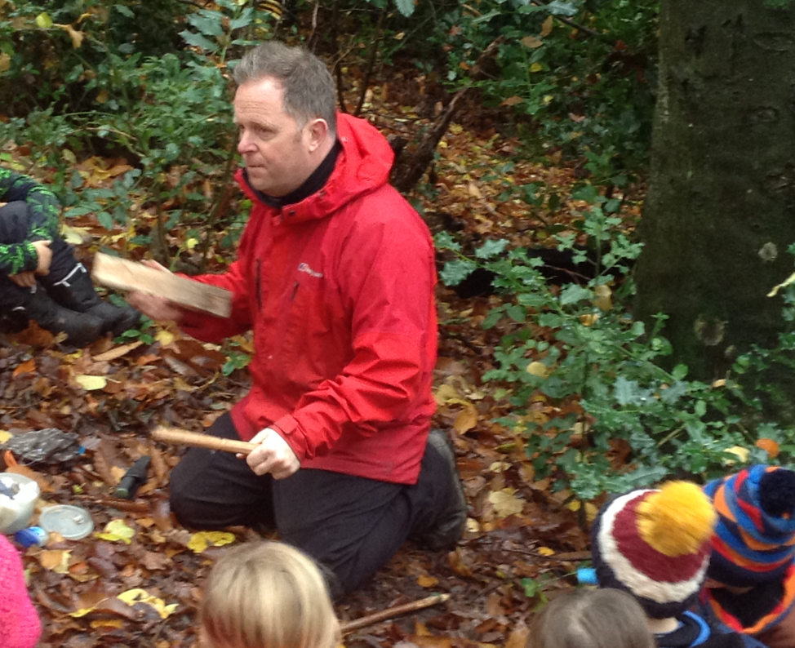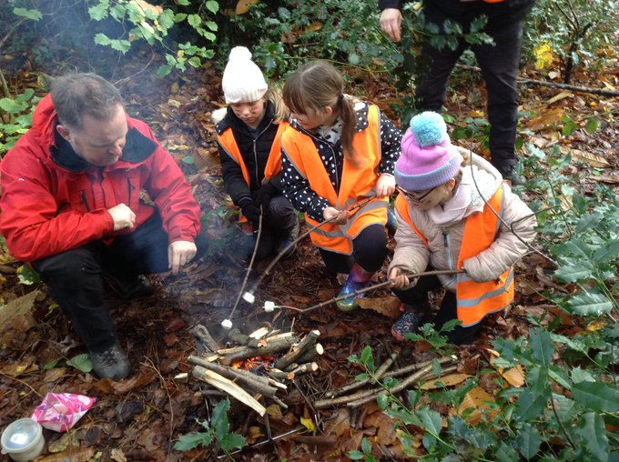
Year 3 went on a Forest School trip. We were all very excited.
Our Forest Schools leader was called Tony. Firstly, we were sorted into tribes because the trip was based on the Stone Age. Mrs Parker gave us special tribe face paint. Then, we built our shelters.
Once we built our shelters, we ate our snack. To build our shelters, we had to put animal skin (fabric) and sticks together. It was very hard! My favourite part of it was getting to work together! We were very hungry so we went to the cafe toilets, played games with Miss Smith and finally, we ate our yummy, scrummy lunches. That took a while.
After lunch, we learnt about fire. Did you know that it takes three hours to actually make a fire by rubbing sticks together?
Next, we made amazing cave art with only natural materials. One piece of art per tribe. Afterwards, tribe by tribe, we got to toast marshmallows on the blazing fire! The best bit!
After that, we sadly packed our bags and went back to school and went home! After school, I was shattered and unable to sleep after such an exciting adventure! :)

By Bea

Teacher Talk
Have you ever wondered what our teachers and helpers around school like? Well we have interviewed some of them to find out their secrets. Read on to find out!

Mrs Smith


What is your favourite Christmas dinner?
100%, a lamb roast dinner.
Why did you become a teacher?
I like learning things every day.
What is the best part of November for you?
The end because it is closer to Christmas.
What is your favourite colour?
Red.
Who do you care about most?
My children.

By Izzie

Dr Anne Jepson


On November the 2nd, a dentist called Anne Jackson visited our school and taught us about how we should take care of our teeth. She told us about how plaque grows on our teeth. Every day if we eat sugar or any other unhealthy items, it grows acid on our enamel. If you don’t know what plaque is, it is this creamy white substance that grows on our teeth, which is why we brush our teeth every day.
She told us about these food colouring tablets that will stick to the plaque on your teeth. If there is no plaque, it will wash away but will stick on to your teeth if there is. You will see spots that haven’t been brushed properly.
She informed us about the different names of teeth and what each one does. The front teeth help us eat our food. They are called incisors. The back teeth help us break the food apart. They are called Molars. Wisdom teeth grow when you are a teenager. You usually have four (one in each corner). Wisdom teeth are the last adult teeth to come into the mouth.
You know how I talked about plaque earlier? Here is some more information!
Plaque is a sticky film of bacteria that keeps growing on your own teeth. Bacteria in plaque produce acids after you consume your daily food. These acids can destroy tooth enamel and cause cavities and gingivitis (gum disease). Plaque can also develop under the gums on tooth roots and break down the bones that support teeth.
Remember to brush your teeth!
By Katie and Fatima
CHRISTMAS

Christmas is getting near
Everyone is full of Christmas cheer

You put up your Christmas tree
Everyone will sing with glee

If you warm your hands with the fire
You will be able to teach a choir

Santa Claus will come in a flash
But then he will leave in a quick dash

Your Christmas elf is very funny
And they like a lot of honey!
By Georgia

Naughty or nice… The Elves have returned!
It’s finally December and that can only mean one thing…around school, many elves have been popping up, getting into all sorts of mischief! 5H’s elf has been hiding behind their tree, while in 3B they have one perched on top of the board! 6H’s is hooked to a pole with a note saying “Who will guide my sleigh tonight?”. 4T has an elf swinging on the door, and 3P’s is sitting in a box of chocolates. 4OT’s elf (Elvis) left them a nice message, buried under test papers, and 5JW Merry Christmas!
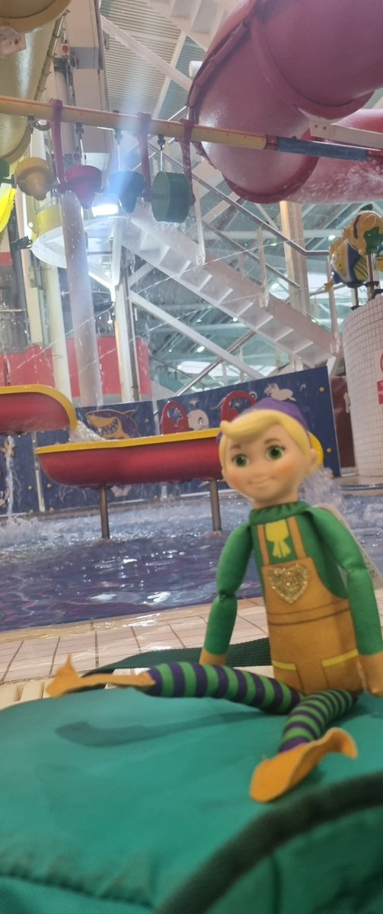
By Benji and Elise

How to make a Starbucks pumpkin spice latte
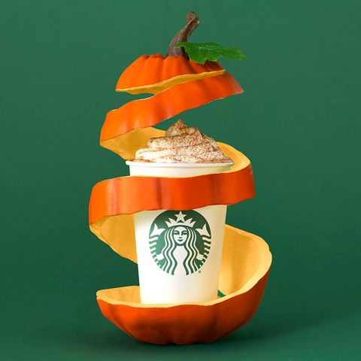

Ingredients for syrup
1 1/2 of cups sugar
11/2 cups of water
6 cinnamon sticks
1 tsp of ground cloves
1 tsp of ground ginger
2 tsp of ground nutmeg
4 tbsp of pumpkin puree

Ingredients for pumpkin spice latte
1 cup of milk
Oz brewed coffee
Tbsp of homemade pumpkin syrup
½ cup of whipped
1 pinch pumpkin pie spice for garnishing

How to make Syrup
Step 01; Combine sugar and water in saucepan and bring to simmer

Step 02; Once sugar is dissolved add Cinnamon sticks, ground cloves, ginger, nutmeg and pumpkin puree and let simmer for 20 mins

Step 03;Remove from heat and immediately drain through cheesecloth.

How to make Pumpkin spiced latte

Step 01; Heat and froth milk

Step 02; Brew coffee

Step 04; Place homemade pumpkin spiced latte syrup in mug followed by hot coffee. Stir together

Step 05; Fill mug with heated milk until ¾ full. Then top with whipped cream

Step 06; Sprinkle with pumpkin pie spice

Enjoy!

Written by Olive

Christmas choir
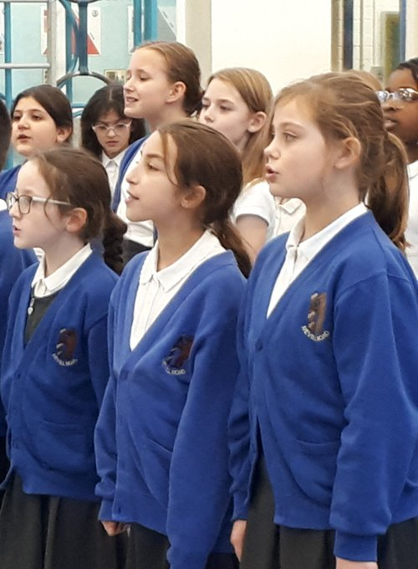

Year 5 and 6 students have been busy this half term practising their songs for the Christmas choir at St George's Church on the 6th of December.
Our supervisor was Mrs. Humphreys from 6H. She taught us a total of 7 songs. On the 23rd November, a visitor came and told us that up to 300 or 400 students can be there from different schools.
There can also be up to 1000 people in the crowd too! Thank you to everyone who came to watch. We hope you enjoyed it.

Environment Poem

Please help save our planet Earth.
For people, nature and all it’s worth.
Please don’t litter.
It’s very bitter.
Let me give you this advice.
Treat the planet nice.
Clean up your litter after you
Encourage others to do it too!

By Georgia

Mince pies

How to make a mince pie:)

Ingredients
225g cold butter, diced
330g plain flour
100g golden caster sugar
280g mincemeat
1 small egg, beaten
Icing sugar, to dust

Method
Step 1
To make the pastry, rub the butter
into the flour, then mix in the golden
caster sugar and a pinch of salt.

Step 2
Combine the pastry into a ball
-don't add any liquid-and knead
briefly- the dough will fairly firm,
Like shortbread dough immediately,
Or chill for later

Step 3
Heat the oven to 200c/180c fan gas 6.
Line 18 holes of two 12- hole patty
tins, by pressing small walnut -
sized balls of pastry into each
hole.

Step 4
Spoon the mince meat into the pies.
Take slightly smaller balls of pastry than
Before and pat them out between your hands
To make round lids, big enough to cover the pies.

Step 5
Top the pies with their lids, pressing
the edges gently together to seal
- you don’t need to seal them with milk
Or egg as they will stick on their own.
Will keep frozen for up to one month.

Step 6
Brush the top of the pies with the beaten egg.
Bake for 20 mins until golden. Leave to cool
In the tin for 5 mins then remove to a wire rack.
To serve, lightly dust with the icing sugar.
Will keep for three to four days in a
Airtight container.
By Charlotte

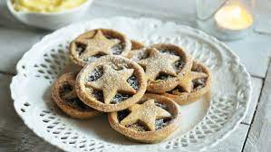

Restorative interviews

We interviewed several Restorative Ambassadors to see if they enjoyed their job.

Number 1
Do you enjoy your job? Yes
Would you recommend this job? Yes I would.
How many arguments do you deal with a day? 3 or 4
Do you solve arguments together? Yes

Number 2
Do you enjoy your job? Yes
Would You recommend your job? Probably, if you like solving arguments
Do you solve arguments together? Yes, mostly

Number 3
Do you enjoy your job? Yes
Would you recommend job? Yes, definitely
How many arguments daily? 5 at least

By Cerys and Benji

Winter fair

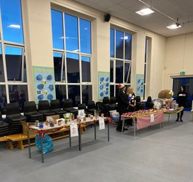
Earlier in this term, the school held the Christmas fair. There were lots of different types of games such as the Tombola, Hook a Hog and Lucky Dip. The Chocolate Tombola was one of the most popular and actually ran out before the fair ended! This year all the Year 6 classes made a game for the school fair. The profits raised from the games will go towards treats like the fish and chips at the end of the year. 6H’s stall was Bubble Bowl, 6C’s Snowball Striker and 6B’s Ping Pong. All of Nevill Road enjoyed the fair. Journalists want to thank the PTA for all the effort they have put in.

By Benji, Elise and Cerys

Festive Scramble!
Guess the festive words!

1) REDEMCBE
2) IWNETR
3) BRELAETCE
4) NWOSAMN
5) ERETS
6) CINREDOATOS
7) BLABUSE
8) STELNI
9) LOYHL
10) VYTINAIT

Christmas Scramble ANSWERS
- DECEMBER
- WINTER
- CELEBRATE
- SNOWMAN
- TREES
- DECORATIONS
- BAUBLES
- TINSEL
- HOLLY
- NATIVITY

Around the world!
Merry Christmas in different languages!

French - Joyeux Noël!
Say: J-why-uh Nor-well!
German - frohe Weihnachten!
Say: Froy-ih Vee-nash-den!
Spanish - Feliz Navidad!
Say: Fe-lize Na-vee-dad!
Italian - Buon Natale!
Say: Bwon Nah-taaah-lay!
Greek - καλά Χριστούγεννα!
Say: Kah-lah Cree-stou-yeh-nah!
Polish - wesołych świąt!
Say: Vair-shtow-ee Ch-yarnt!
Russian - С Рождеством!
Say: Slair-zh Deesty-vom!
Swedish - God Jul!
Say: Gord-zh Yul!
Japanese - メリークリスマス!
Say: Mairrr-ee Kuh-ree-suh-mah-suh
Dutch - Vrolijk kerstfeest!
Say: Frow-lick Kairst-faist
Turkish - Mutlu Noeller!
Say: Mut-floo No-wair-lazh
Norwegian - God jul!
Say: Gou Yool!
By Elise

Christmas colouring!
Fill in Santa!

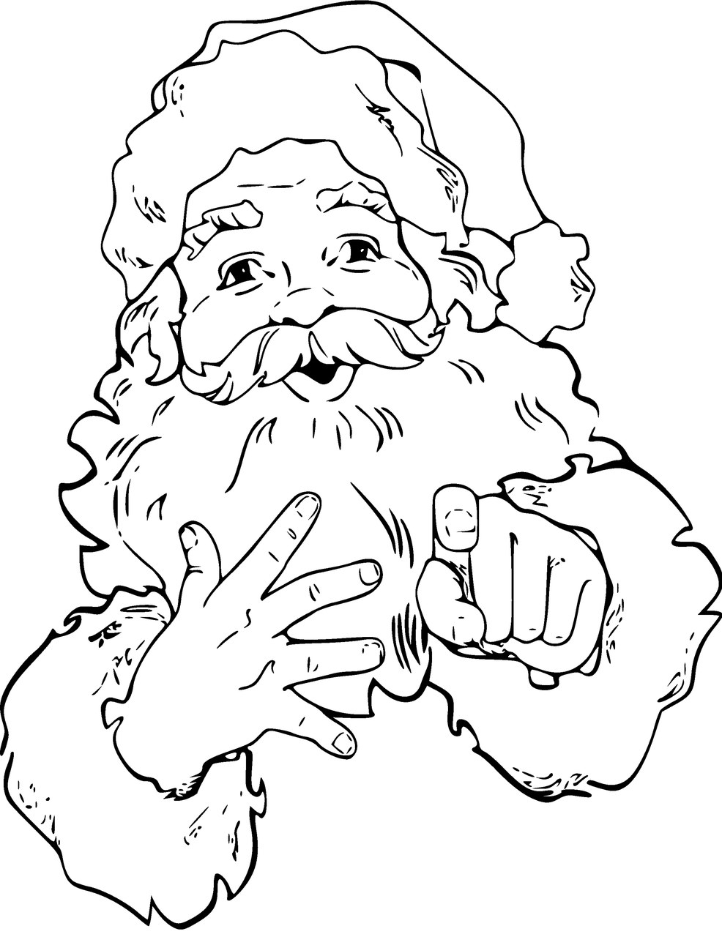

Wishing all of Nevill Road a Merry Christmas and a Happy New Year from our journalists!

