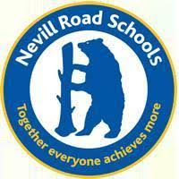
Nevill Road Junior School
Parent Newsletter – 7.5.21

Dear families,
I hope you enjoyed the Bank Holiday weekend and managed to enjoy some family time together. Our after school sports clubs are now up and running which include multi sports, football and cricket. Please contact the office for more details.
The Recovery Curriculum
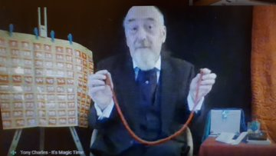
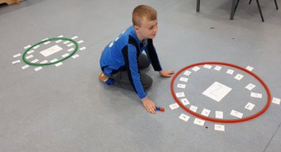
Our NSPCC Numbers day was a huge success. The children loved finding out about magical maths tricks from Tony Charles. All around school there was a happy buzz of excitement with active learning and maths investigations taking place in a variety of ways. We managed to raise £184.50 for the NSPCC. Please see the following website for more information about how to keep our children safe and resources which may help. https://www.nspcc.org.uk/
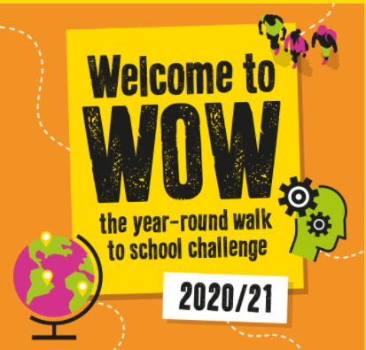
This May, we have linked up with the WOW Walk to School campaign run by Living Streets. This is a pupil-led initiative where children report how they get to school every day using the interactive WOW Travel Tracker. If they travel sustainably (walk, walk some of the way, cycle or scoot) once a week for a month, they will be given a badge. Children will be introduced to WOW during Circles lessons in the next week. If you would like to find out more about Living Streets and their campaign, please click on the link below. https://www.livingstreets.org.uk/products-and-services/projects/wow
Please be reminded to park / drive safely and responsibly whilst dropping off and collecting children from school.
Staffing News
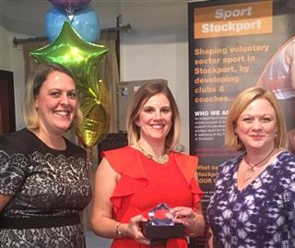
I am very sad to share that Mrs Sheldrake will be leaving us at the end of this year. She has been regularly volunteering for St. John’s Ambulance during the pandemic and would like to pursue a career with the NHS. Our entrance area, full of sports trophies including the Stockport Sports Award, is a tribute to all of her hard work and the huge number of opportunities that she has provided for our children during her time at the school. She will be greatly missed and we wish her all the very best for her future.
Healthy Snacks
Please be reminded that we promote healthy eating at Nevill Road and are a nut free school due to children and adults having allergies.
Homework
Homework is now set weekly through Google Classroom and is to be completed by Tuesday. Tasks are provided to help children revise their learning from the week before and help them to catch up on key learning skills.
Dates for the Diary
Wednesday 12th May – Year 2 Parent Meeting, 5.30pm
Monday 17th May – Year 3 SEND reviews
Tuesday 18th May – Year 4 SEND reviews
Monday 24th May – Year 3 & 5 SEND reviews
Tuesday 25th May – Year 6 SEND reviews
- Year 2 SEND transition meetings
Friday 28th May – PTA Break the Rules Day – information to follow
- Last day of half term

Kind regards
Mrs Cliff
Together Everyone Achieves More

