To listen to and follow instructions.

To play in safe areas of the playground where an adult can see you.

To walk in school.

To keep your hands and feet to yourself.

To stop when the whistle blows and line up safely.

To remember not to slide tackle.

To sit properly on chairs – all four feet.

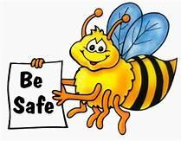

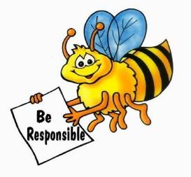

To look after school equipment and property.

To make good choices and always be honest.

To use your best presentation in all lessons.

To keep your classroom and cloakroom tidy.

To complete your homework every week.

To throw away your litter in the bin.

To be kind and help others.

To respect other’s differences.

To listen and always follow instructions.

To respect school property.

To use good manners and wait your turn.

To remember that we are a TEAM.

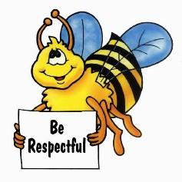

To arrive at school on time and have your equipment ready.

To line up silently and come in to class ready to learn.

To write the LO quickly and underline.

To show you are listening, 5 - 0 eyes and knees facing the teacher.

To walk around school inside and outside, sensibly and calmly.

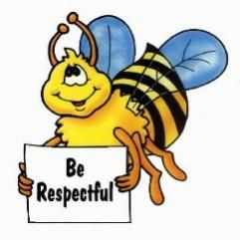

**Ready**

**T**ogether **E**veryone **A**chieves **M**ore