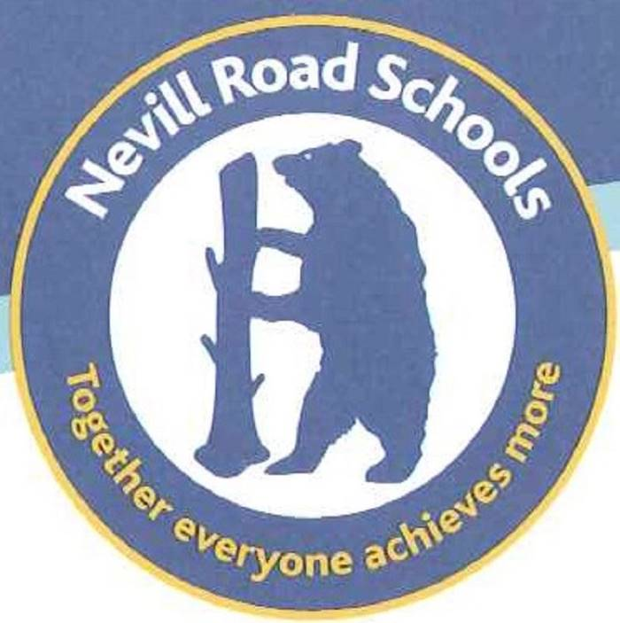

Nevill Road Junior School

Title | First Aid Policy
Author | Nevill Road Junior School
Approved by | Full Governors
Review Date

Aims:

The aims of our first aid policy are to:

- Ensure the health and safety of all staff, pupils and visitors
- Ensure that staff and governors are aware of their responsibilities with regards to health and safety
- Provide a framework for responding to an incident and recording and reporting the outcomes

Legislation and guidance

- The Health and Safety (First Aid) Regulations 1981, which state that employers must provide adequate and appropriate equipment and facilities to enable first aid to be administered to employees, and qualified first aid personnel
- The Management of Health and Safety at Work Regulations 1992, which require employers to make an assessment of the risks to the health and safety of their employees
- The Management of Health and Safety at Work Regulations 1999, which require employers to carry out risk assessments, make arrangements to implement necessary measures, and arrange for appropriate information and training
- The Reporting of Injuries, Diseases and Dangerous Occurrences Regulations (RIDDOR) 2013, which state that some accidents must be reported to the Health and Safety Executive (HSE), and set out the timeframe for this and how long records of such accidents must be kept
- Social Security (Claims and Payments) Regulations 1979, which set out rules on the retention of accident records
- The Education (Independent School Standards) Regulations 2014, which require that suitable space is provided to cater for the medical and therapy needs of pupils

Roles and responsibilities
Appointed person(s) and first aiders

The school will appoint a first aid lead. They are responsible for:
- Ensuring there are competent First Aiders when someone falls ill or is injured.
- Ensuring there is an adequate supply of medical materials in first aid kits, and replenishing the contents of these kits
- Ensuring that an ambulance or other professional medical help is summoned when appropriate

First aiders are trained and qualified to carry out the role and are responsible for:
- Reacting to any incidents; they will assess the situation where there is an injured or ill person, and provide immediate and appropriate treatment
- If they deem the incident to be of a serious nature they will call the first aid lead. In the absence of the first aid lead call another member of staff with paediatric first aid training.
- Sending pupils home to recover, where necessary
- Filling in an accident report on the same day, or as soon as is reasonably practicable, after an incident using medical tracker
- Keeping their contact details up to date

The Headteacher

The Headteacher is responsible for the implementation of this policy, including:
- Ensuring that an appropriate number of appointed persons and/or trained first aid personnel are present in the school at all times
- Ensuring that first aiders have an appropriate qualification, keep training up to date and remain competent to perform their role
- Ensuring all staff are aware of first aid procedures
- Ensuring appropriate risk assessments are completed and appropriate measures are put in place
- Undertaking, or ensuring that managers undertake, risk assessments, as appropriate, and that appropriate measures are put in place
- Ensuring that adequate space is available for catering to the medical needs of pupils
- Reporting specified incidents to the HSE when necessary

Staff

School staff are responsible for:
- Ensuring they follow first aid procedures
- Ensuring they know who the first aiders in school are
- Completing accident reports for all incidents they attend to where a first aider is not called
- Informing the Headteacher or their line manager of any specific health conditions or first aid needs in timely fashion

First aid procedures

In-school procedures
In the event of an accident resulting in injury:

- The closest member of staff present will assess the seriousness of the injury and seek the assistance of a qualified first aider, if appropriate, who will provide the required first aid treatment.
- The first aider, if called, will assess the injury and decide if further assistance is needed from the first aid lead or the emergency services. They will remain on scene until help arrives.
- The first aider will also decide whether the injured person should be moved or placed in a recovery position, with consent of the injured party
- If the first aider judges that a pupil is too unwell to remain in school, parents will be contacted and asked to collect their child. Upon their arrival, the first aider will recommend next steps to the parents.
- If emergency services are called, another member of staff will contact parents immediately.
- The first aider on the scene will complete an accident report on medical tracker as soon as is reasonably practical after an incident resulting in an injury and send notification to the child’s first contact via email that was provided to the school upon admission.

Off-site procedures

When taking pupils off the school premises, staff will ensure they always have the following:
- A mobile phone
- A portable first aid kit
- Information about the specific medical needs of pupils
- Parents/carers contact details

Risk assessments will be completed by the school prior to any educational visit that necessitates taking pupils off school premises with specific reference to children with medical needs.

There will always be at least one first aider.

For more information regarding accompanying school trips and visits see Educational visits policy.

Personal Medication and Children with Known Medical Conditions or Food Allergies

If any child is receiving prescribed medication the office staff are able to administer the medicine at school if form 3A has been completed and signed by the parent/guardian. All prescribed medication is stored securely in the school office. For children with a known condition the parents will have to fill in an Individual Health Care Plan (IHP) and Form 3A so a trained first aider can administer the medicine.

In cases where the children require immediate access to medication such as asthma, the medication will be kept in the classroom. If a child takes an inhaler, the appropriate slip should be filled in and sent down to the Office by a member of staff, the office will then complete the medication given form on medical tracker and send notification to the parent. All children requiring an inhaler must use a spacer and be supervised whilst taking it.

All class teachers will have an up to date list of children requiring such medication, including food allergies via medical tracker and the school drive.

All members of staff are asked to read and acknowledge children with known medical conditions and any action which may be required for them.

All staff will have annual first aid training for asthma and epi-pens. In the case of a child who is diabetic or epileptic, all staff who work closely with the child will have specific training. A named member of staff will notify parents if there are any medical concerns regarding the child’s insulin levels.

Equipment

The First Aid equipment is situated in the 2 main corridors (taken outside to the playgrounds at lunch time) and in the school office, Incidents are logged via Medical Tracker using a school laptop or Ipad. First Aid kits for school trips etc are provided to the named first aider on the risk assessment ahead of the visit.

Record-keeping and reporting

First aid and accident recording system – Medical Tracker

- An accident form will be completed by the first aider on the scene on the same day or as soon as possible after an incident resulting in an injury
- As much detail as possible should be supplied when reporting an accident, including all of the information included in the Injury form.
- Records held in Medical Tracker (plus the old first aid and accident book) will be retained by the school until they need to be disposed of securely, A senior member of staff will review the accident forms weekly.

Reporting to the HSE

The Headteacher with responsibility for Health and Safety will keep a record of any accident which results in a reportable injury, disease, or dangerous occurrence as defined in the RIDDOR 2013 legislation (regulations 4, 5, 6 and
7).

The Headteacher with responsibility for Health and Safety will report these to the Health and Safety Executive as soon as is reasonably practicable and in any event within 10 days of the incident.

Reportable injuries, diseases or dangerous occurrences defined in:

- Death
- Injuries where an employee is away from work or unable to perform their normal work duties for more than 7 consecutive days (not including the day of the incident)

Information on how to make a RIDDOR report is available here:

How to make a RIDDOR report, HSE
http://www.hse.gov.uk/riddor/report.htm

Notifying parents

Parents will be notified of any accident or injury sustained by a pupil, and any first aid treatment given, on the same day via email.

Any injury to the head MUST be treated as high priority: an email will be sent outlining details of head injuries and symptoms to look out for to the parent; they should also be provided with a wristband. The staff member who deals with the injury should also ensure that parents have received a telephone call if the injury is deemed more serious and the pupil is showing concerning symptoms, a follow up email would will be sent after the phone call.

Reporting to Ofsted and child protection agencies

The Headteacher will notify Ofsted of any serious accident, illness or injury to, or death of, a pupil while in the school’s care. This will happen as soon as is reasonably practicable, and no later than 14 days after the incident.
The Headteacher with responsibility for Health and Safety will also notify local child protection agencies of any serious accident or injury to, or the death of, a pupil while in the school’s care.

Training

All school staff are able to undertake first aid training if they would like to.
All first aiders must have completed a training course, and must hold a valid certificate of competence to show this. The school will keep a register of all trained first aiders, what training they have received and when this is valid until.

This will be displayed on Health and Safety noticeboards and updated regularly. Staff are encouraged to renew their first aid training when it is no longer valid.

Monitoring arrangements

This policy will be reviewed by the Headteacher and Governor in charge of Health and Safety.

At every review, the policy will be approved by the Headteacher and Governing body.

Links with other policies

This first aid policy is linked to the

- Health and safety policy
- Policy on supporting pupils with medical conditions
- Educational Visits policy

Personal Medication and Children with Known Medical Conditions or Food Allergies

If any child is receiving prescribed medication a responsible adult will have to come to administer the medicine at school. On no account should teachers give medicines, pills or ointment to children. For children with a known condition the parents will have to fill in an Individual Health Plan (IHP) and Form 3A so a trained first aider can administer the medicine.

In cases where the children require immediate access to medication such as asthma, the medication will be kept in the classroom. If a child takes an inhaler within the classroom, the appropriate slips should be filled in and one sent down to the Office and the other to be taken home by the child. All children requiring an inhaler must use a spacer and be supervised whilst taking it.

All class teachers will have an up to date list of children requiring such medication, including food allergies.

All members of staff are asked to read and acknowledge children with known medical conditions and any action which may be required for them.

All staff will have annual first aid training for asthma and epipens. In the case of a child who is diabetic, all staff who work closely with the child will have specific training. A named member of staff will notify parents if there are any medical concerns regarding the child’s insulin levels.


NEVILL ROAD JUNIOR SCHOOL
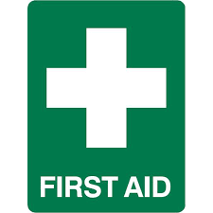

First Aid Lead
Nicola Jordan

Emergency First Aid & Paediatric Level 3
Ronel Lord – TA (exp Nov 2026)
Nicola Jordan – Deputy Head (exp Mar 2025)

EMERGENCY FIRST AID
Adam Baguley – 5/6 Phase Leader (exp Nov 2025)
Tanya Smith – TA (exp Oct 2025)
Keeley Hopkins – Admin (exp July 2026)
Isla Everhard – TA (exp July 2026)
Carrie Kielty – TA (exp July 2026)
Helen Barry – TA (exp July 2026)
Sue Hindle – TA (exp July 2026)
Maggie Chung – Midday (exp July 2026)
Julie Longman – TA (exp July 2026)
Liz Dolan – TA (exp July 2026)
Suzie Hewson – TA (exp March 2027)
Heather Jones – TA/Midday (exp July 2027)
Tom Nash – Business Manager (exp July 2027)
Kirsty Slee – TA (exp July 2027)
Sharon Baird – Teacher (exp July 2027)
Ella Mullin - Teacher (exp July 2027)
Lisa Dale - Teacher (exp July 2027)
Mike Kinnear - Teacher (exp July 2027)
Ellie Fripp - Teacher (exp July 2027)
Hayley Newbould - Teacher (exp July 2027)
Lucy Godridge - Teacher (exp July 2027)
Alex Taylor - Teacher (exp July 2027)
Jemma Hancock - Teacher (exp July 2027)

Mental Health First Aid
Keeley Hopkins – Admin (exp July 2027)

Medicines are held in designated classrooms and the School Office for administration (refer to IHP & Form 3B)

